Web Dev I Lab Assignment 5
Capstone – Responsive Website Project
Problem Statement
Build a fully structured, responsive web interface using HTML5 & CSS3, demonstrating real-world layout, semantic structure, and visual design.
Choose one theme:
- Online Learning Platform: Landing page with course cards, testimonials, pricing, and contact form.
- Real Estate Listing Platform: Property grid with filters, image galleries, and agent info sections.
- Fintech Dashboard: UI for financial services showing transaction cards, stats, and pricing plans.
- Food Delivery App: Menu page with featured items, category filters, restaurant cards.
- Travel Agency Website: Tour packages with banners, reviews, itinerary sections, and inquiry form.
- E-commerce Store UI: Product listing, filter sidebar, and product detail layout with add-to-cart UI.
Requirements:
Use only HTML5 & CSS3 (Flexbox/Grid mandatory).
Apply responsive design using media queries.
Structure must follow semantic HTML practices.
Include forms, lists, images, and navigation links.
Showcase custom styling, hover effects, and good use of fonts & colors.
Outcome:
A fully responsive, visually polished, and semantically correct static site representing a real-world use case.

Objective:
Build a fully structured, responsive web interface using HTML5 & CSS3, demonstrating real-world layout, semantic structure, and visual design.

Learning Outcomes
Upon completion of this assignment, the students will be able to:
- Understand and apply HTML5 semantic elements to structure web pages meaningfully.
- Build fully responsive layouts using CSS3 Flexbox and Grid techniques.
- Implement media queries to adapt the interface across different screen sizes.
- Design visually appealing web pages with custom fonts, colors, and hover effects.
- Create functional forms, lists, navigation menus, and interactive UI elements.
- Develop real-world themed websites such as e-commerce, travel, fintech, or food delivery, reinforcing practical design skills.
- Learn to organize and structure content logically for user-friendly navigation.
- Apply visual hierarchy and spacing principles to improve readability and aesthetics.
- Integrate images, banners, and cards effectively for dynamic content presentation.
- Gain experience in full-page layout design, combining responsiveness, semantic structure, and modern CSS techniques to build professional web interfaces.

Detailed Instructions

- Project setup
  - Choose one theme from the list (Online Learning, Real Estate, Fintech, Food Delivery, Travel, E-commerce).
  - Create project folder with index.html, style.css, images/, and README.md.
  - Use semantic sections: <header>, <nav>, <main>, <section>, <article>, <aside>, <footer>.
- Required sections (pick & adapt to theme)
  - Header / Nav: logo, brand name, primary navigation (internal links), “Skip to main content”.
  - Hero / Banner: large banner with title, short tagline, CTA button.
  - Core content: at least three content sections relevant to theme (e.g., course cards + testimonials + pricing for Online Learning). Use <article> or card components.
  - List/Grid: display items (courses, properties, products, menu items) using CSS Grid.
  - Sidebar / Filters (optional for theme like e-commerce / real estate): filter controls (visual only — no JS required).
  - Forms: inquiry/contact or sign-up form with label, required, placeholders.
  - Footer: contact links, social icons (SVGs), copyright.
- Layout & responsiveness
  - Use Flexbox for header/footer/alignment and CSS Grid for card layouts.
  - Define CSS variables for colors, fonts, spacing (:root).
  - Use relative units (rem, em, %, vw) and a root font-size.
  - Implement at least two breakpoints: desktop (≥1024px), tablet (~768px), mobile (≤480–600px). At ≤768px make grid single-column and stack header items.
- Visual polish
  - Use consistent color palette and typography (Google Fonts allowed).
  - Add subtle hover effects, transitions (transition: all 0.25s ease), and one keyframe animation (e.g., hero fade/slide).
  - Ensure good contrast and readable font sizes.
- Accessibility & performance
  - All images include meaningful alt.
  - Use aria-label where appropriate (navigation toggles if present).
  - Ensure form fields have associated <label>.
  - Optimize image sizes (use appropriately scaled images).
- Deliverables
  - Fully functioning static site viewable locally or via GitHub Pages (optional).
  - README.md describing theme, features, breakpoints, and how to run/view site.
  - Optional: include screenshot-desktop.png and screenshot-mobile.png in repo.

Expected Output

4. Online Learning Platform:

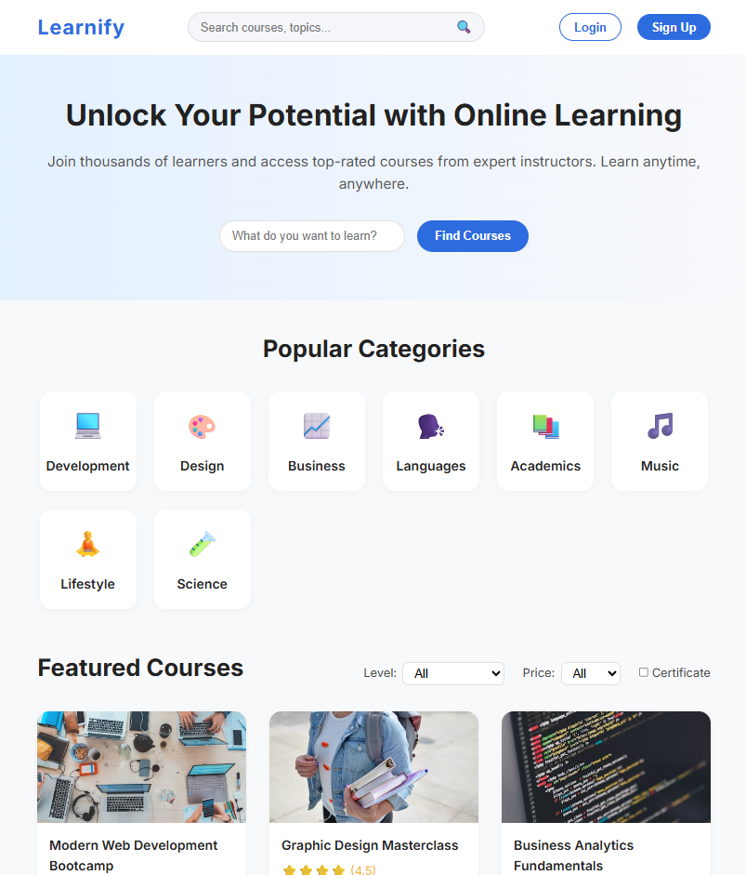

3. Real Estate Listing Platform

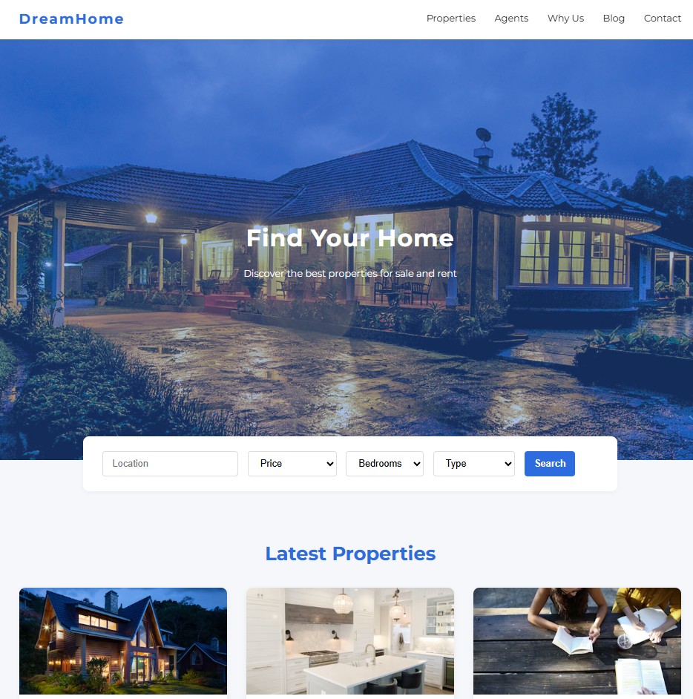
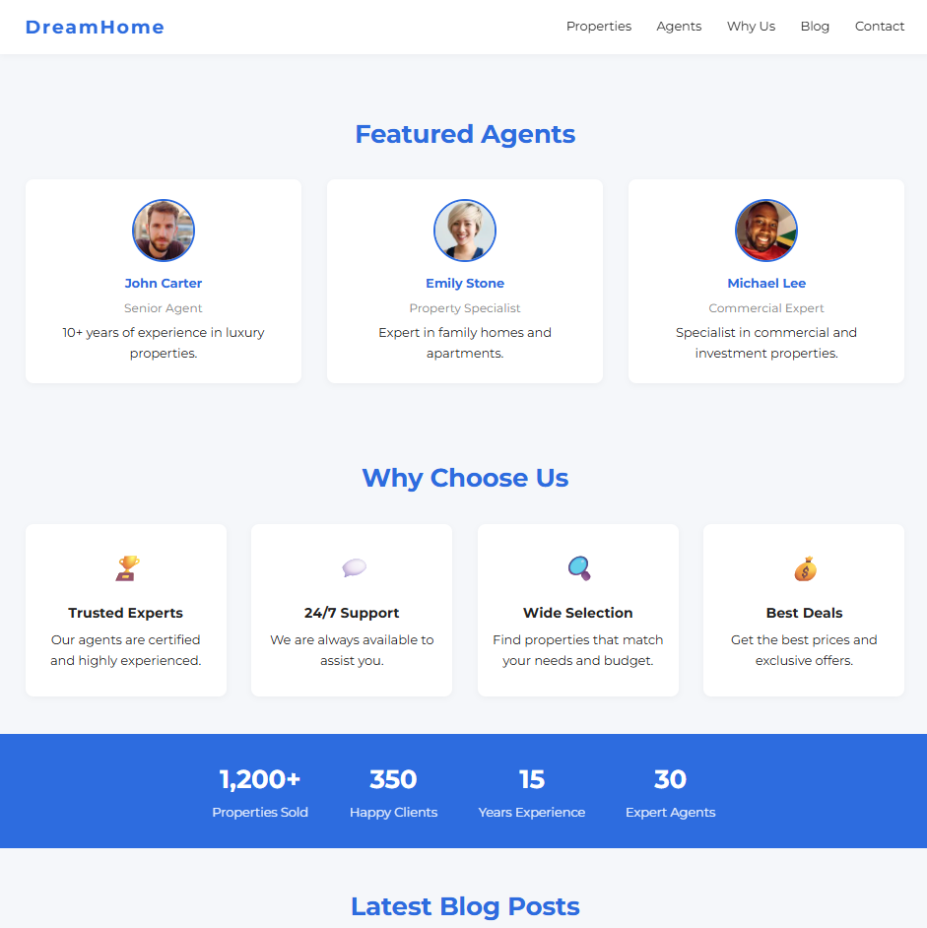

5.Fintech Dashboard

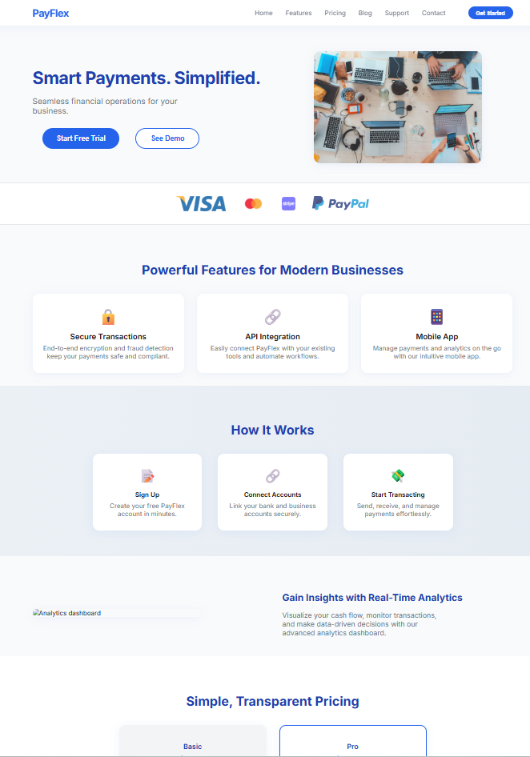

2. Food Delivery App

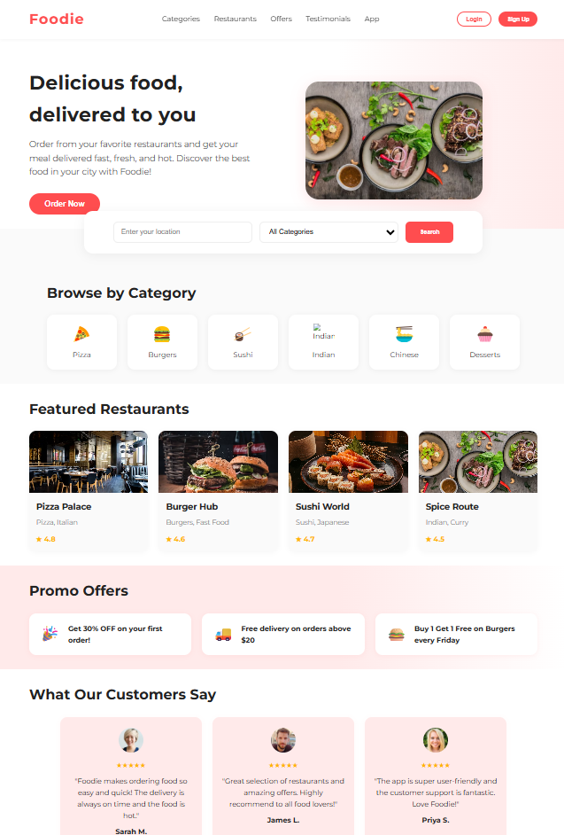

6. Travel Agency Website

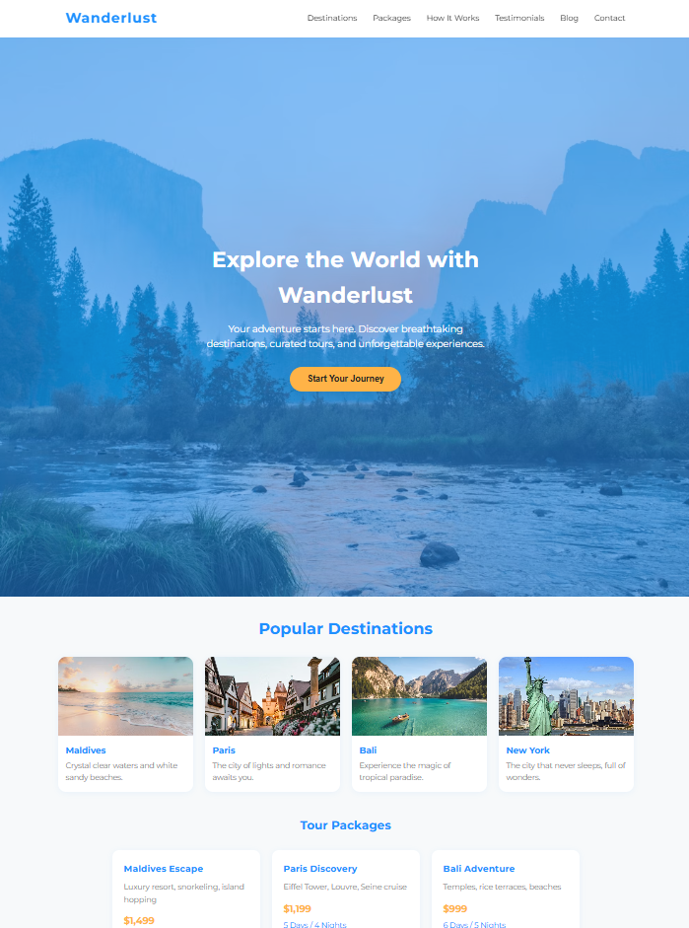

1. E-commerce Store UI

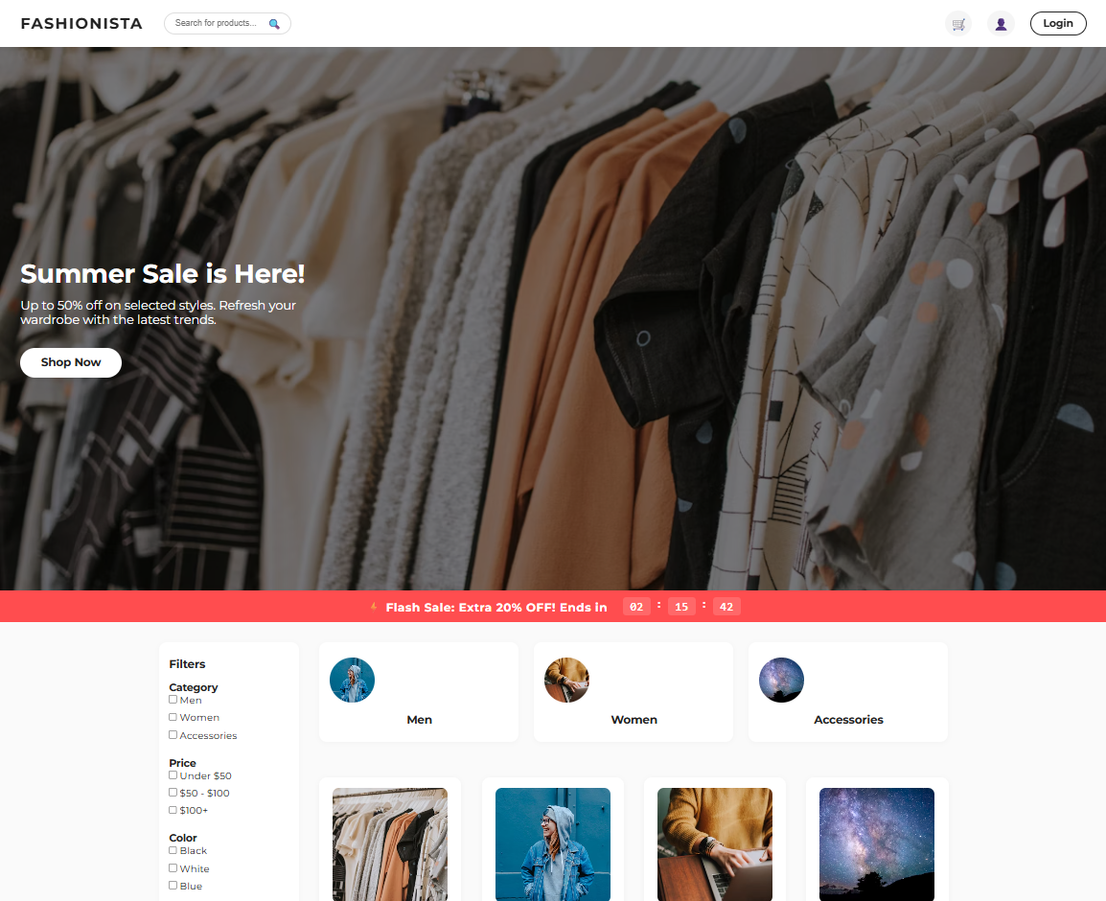

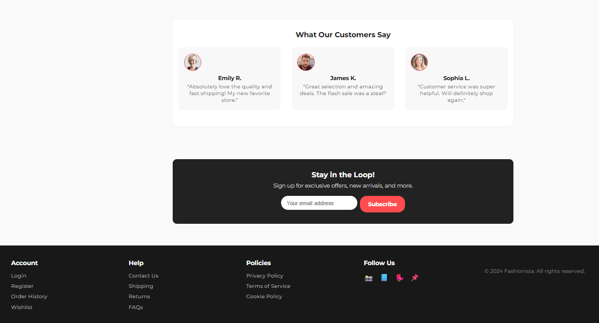

Guidelines to Students
- Understand the Project Theme:
Read the project instructions carefully and choose one theme (Online Learning, Real Estate, Fintech, Food Delivery, Travel Agency, or E-commerce). Understand what sections and features are expected for that theme.
- Plan the Layout Before Coding:
Sketch a rough layout or wireframe on paper or digitally. Decide the placement of headers, banners, cards, forms, menus, and other sections to organize the content clearly.
- Use Semantic HTML5 Elements:
Structure the website using proper HTML tags like header, footer, main, section, article, nav, and aside. This improves readability, accessibility, and SEO.
- Apply Responsive Design:
Use CSS Flexbox and Grid to create flexible layouts that adjust automatically to different screen sizes. Add media queries to handle tablets, mobile phones, and large screens.
- Design with Consistent Styling:
Choose fonts, colors, and spacing that look consistent across all pages. Use hover effects, shadows, and other styling techniques to make the website visually appealing.
- Include All Required Components:
Add forms, lists, images, banners, navigation links, buttons, and cards as per the theme. Make sure each component is functional and fits the design.
- Optimize Visual Elements:
Use high-quality images, icons, and illustrations. Compress images if needed to improve loading speed. Ensure all visuals are aligned and sized correctly.
- Test Interactivity and Functionality:
Check that navigation menus, buttons, links, and forms work as expected. Test hover effects, responsiveness, and alignment across different browsers and devices.
- Maintain Clean and Organized Code:
Keep HTML and CSS files organized and readable. Use comments to mark sections if needed. Avoid unnecessary code repetition.
- Refine and Improve:
After completing the basic site, make improvements such as adding animations, adjusting spacing, refining typography, or enhancing responsiveness. Ensure the website looks polished and professional.

Improvements/Adjustments
- Enhance the responsiveness of the website by adding more detailed media queries to handle different screen sizes including small phones, tablets, and large desktops.
- Refine visual design by applying gradients, shadows, transitions, and hover animations to make the site more interactive and appealing.
- Improve typography with custom fonts, proper line heights, and consistent font weights to enhance readability.
- Optimize color schemes to follow accessibility standards and ensure sufficient contrast for all text and interactive elements.
- Organize content layout with proper spacing, alignment, and hierarchy to guide users naturally through the site sections.
- Add interactive elements such as dropdown menus, tabs, or accordions to improve user engagement and navigation experience.
- Optimize images and media assets for faster loading and better visual quality, including using icons and illustrations effectively.
- Ensure semantic HTML is properly used throughout the site, including headers, footers, navigation, and content sections for better accessibility and structure.
- Plan the site for scalability by designing reusable components and layouts that allow future expansion or addition of new features without breaking responsiveness.
- Maintain consistency in design elements like buttons, cards, menus, and spacing across all pages to provide a professional and cohesive look.

Submission Guidelines

- Create a GitHub repository named capstone- Student Name lab5.
- Push project files (index.html, style.css, images/, README.md, screenshots).
- Ensure README.md contains:
  - Project title & theme
  - Short description of sections implemented
  - Breakpoints used and main layout techniques
  - How to open (local) and optional GitHub Pages link
- Share the GitHub repository link with the concerned faculty before the deadline.

Performance Metrics (Out of 20 Marks)

Criterion | Marks
Layout & Structure | 4
Responsiveness | 4
Visual Design & Styling | 4
Output Matches Expected Design | 4
Documentation & Submission | 4

